Seam Sealer Applicator for 400 ml Cartridge
Model VR400A85 comes assembled ready for 1:1 ratio use with 400 ml cartridges. See instructions below for conversions of 2:1, 4:1, and 10:1 cartridge ratio use.
Instructions for Removing Push Disks
- Place applicator with knob on floor.
- Put both thumbs on front plate and fingers behind the disk you desire to remove.
- Move fingers forward toward thumbs until disk snaps off rod. If the disk is hard lo remove, use a rubber mallel and gently tap until disk becomes loose.
- See Dlslr Assembly Diagram for proper ratio alignment.

Instructions for Attaching Push Disks
- Put socket of push disk over rod shaft.
- Push firmly onto Ihe rod shaft until dlsk snaps in place. There should be two snapping sounds which will ensure the disks are firmly attached. Some twisting of the push disk may be required to achieve lhe second snap.
- Both disks should be parallel with each other. This wi!! ensure proper mixing of materials.

FROUTPtAF£
olsxs must be on the correct side of lhe p]slon rod. II you are facing the outside al Ihe front plale (see diagram), Ihe disks under 'L’ should be on The left hand side and the disks under ‘R" should be on the right hsnd side ol Ihe
lan rod.

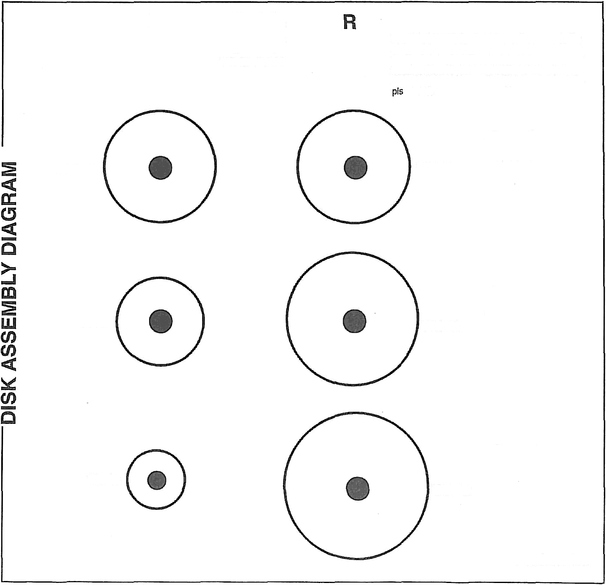
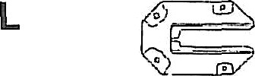

VR4-36

VR4-28

VR-19

VR4-36

VR4-42

'VR4-46
1:1

2:1

4:1

Continued....

Seam Sealer Applicator for 400 ml Cartridge (continued)

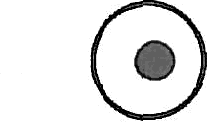
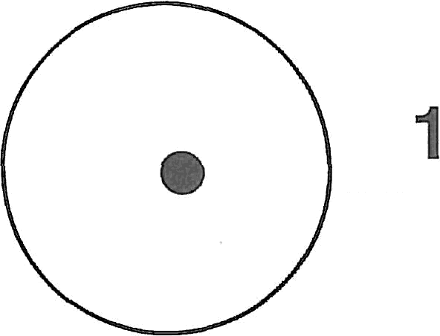
0:1

VR-15
VR4-56

